**Report**

**Manual**

**Key**

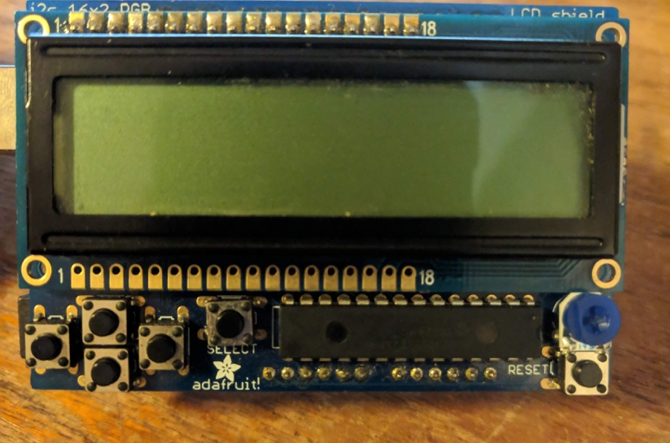

1. UP

4. LEFT

2.DOWN

6.RESET

5.SELECT

3.RIGHT

1. UP button. Press to execute UP command in the game
2. DOWN button. Press to execute DOWN command in the game
3. RIGHT button. Press to execute RIGHT command in the game
4. LEFT button. Press to execute LEFT command in the game
5. SELECT button. Press to access the menu and pause the game
6. RESET button. Press to restart Arduino

Instructions to play the game

1. Start page: Press “UP ” to load a saved pet or press “DOWN” to start a new game

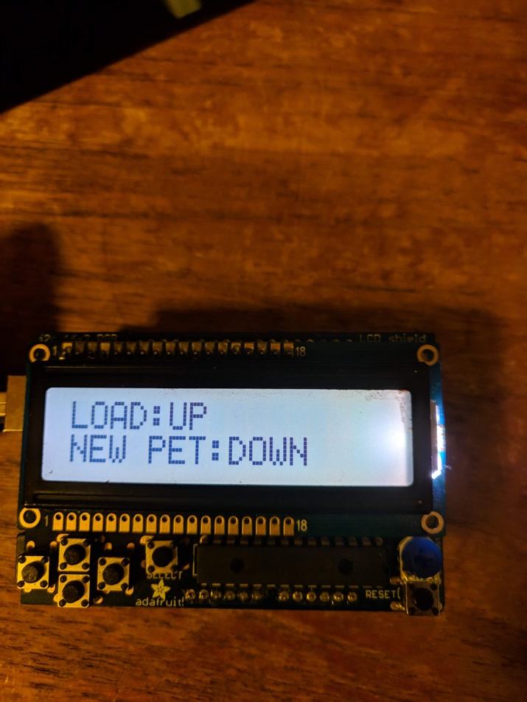

1. Game main page: this page displays all the statistics of the current pet. “DEV” is Development stage, which Is 0(egg), 1(young), or 2(adult). “HAPPY” is Happiness level, which is 0(unhappy), 1 (Content), or 2(happy). “FULL” is Fullness level, which is 0(ravenous), 1(hungry), 2(peckish), 3(full), or 4(overfull). ”AGE” is the time since the new pet was created in minutes and seconds.

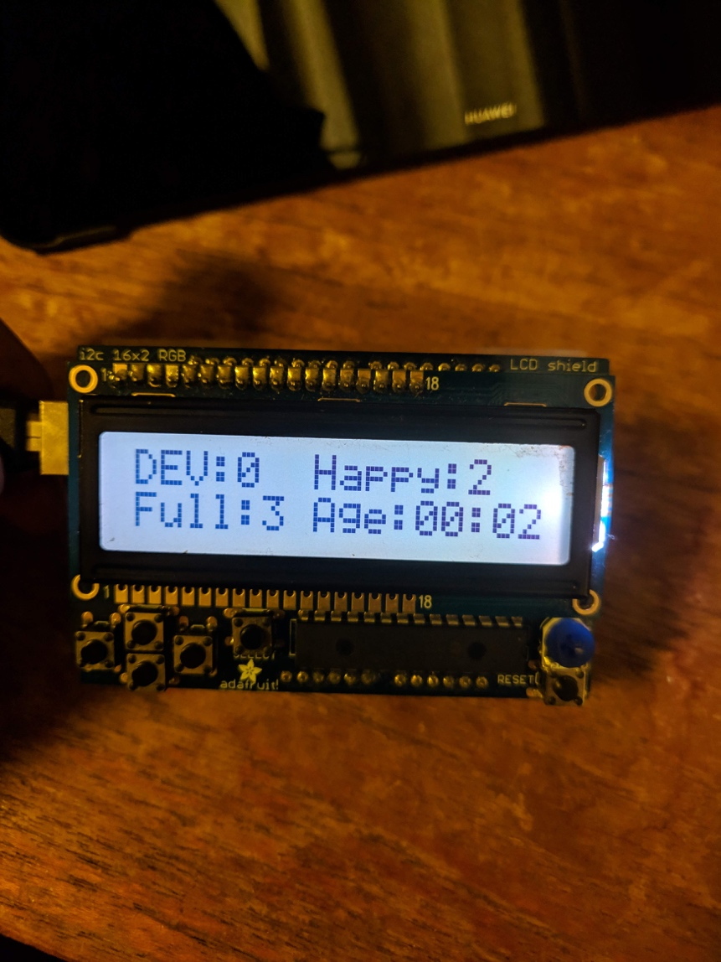

1. On this page the user can press UP to feed the pet, DOWN to play with pet and LEFT to grow the pet(level up).

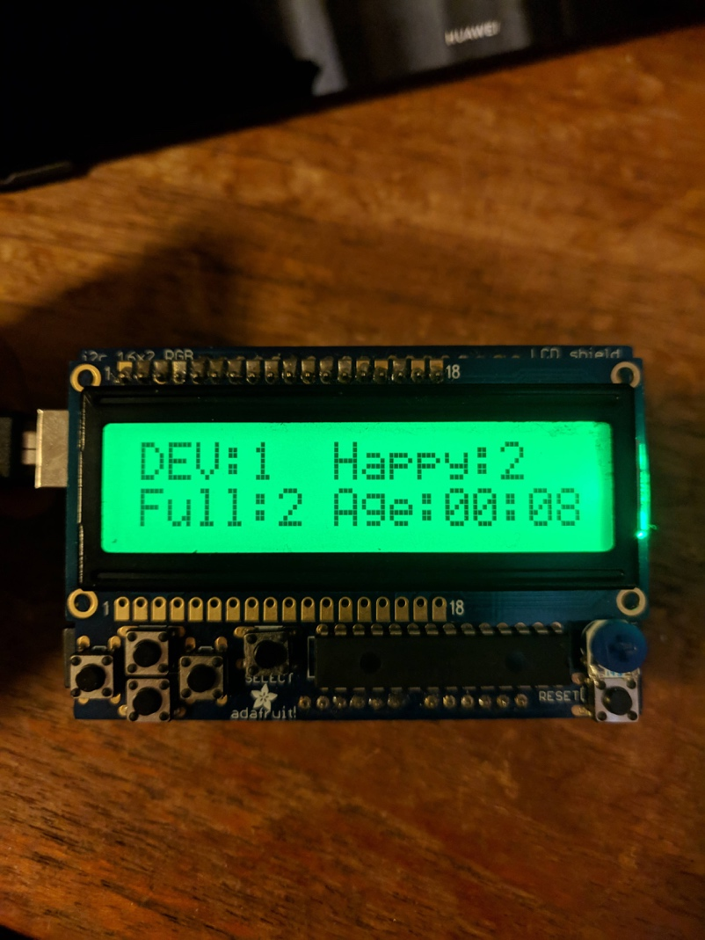

1. While on main page the user can press the SELECT button to pause the game and enter the menu. From the menu the user can press UP to return back to the main page, press DOWN to start a new pet and restart the game, press RIGHT to save the pet and quit the game or press LEFT to delete the saved file.

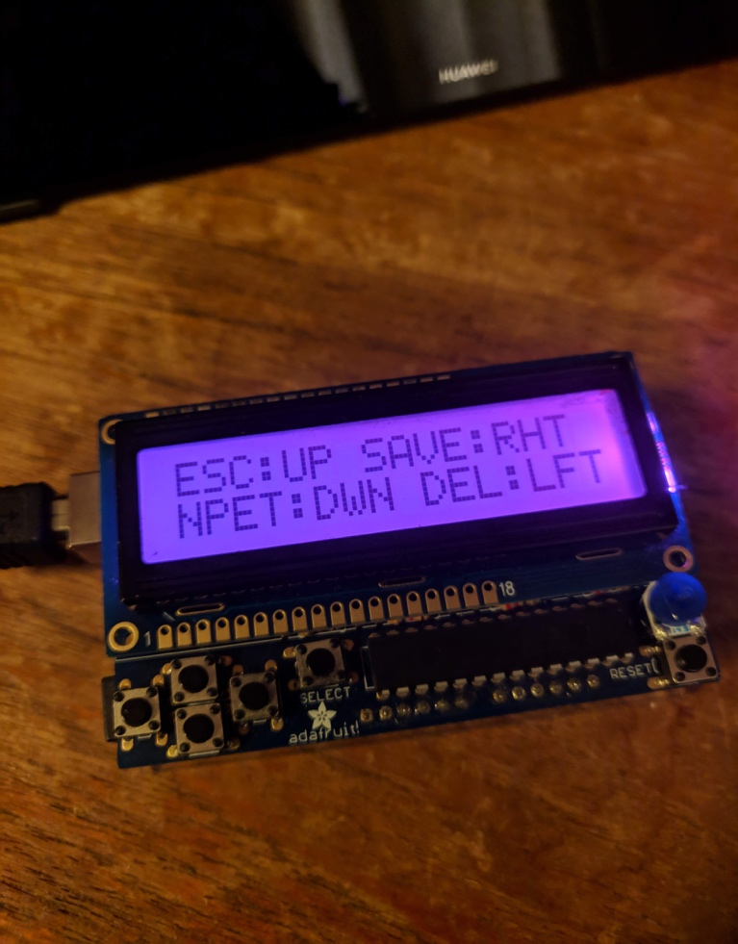

**List of features**

All features that was required in the specification was implemented to the full extent.

* Load Saved pet- feature loads saved pets information from memory and let user resume from the point the game was saved- fully implemented.
* New pet- feature creates a new pet and set the starting values-fully implemented
* Countdown for age- represented by age is the time since game was started-fully implemented
* Grow pet- set the development stage to young (1) after 5 seconds and set development stage to 2 when age is at least 35 seconds and happiness is at least 1 and fullness is at least 3-fully implemented
* Reduce happiness every 7 seconds and fullness every 11 seconds and if fullness reaches 0 and happiness set to 0-fully implemented
* Feed pet- increase fullness by 1 if fullness is less than 3 and if fullness is 4 happiness is set to 0-this feature was fully implemented;
* Play with pet increases happiness by 1 if happiness is less than 2 and fullness is at least 2 -fully implemented;
* Game menu accessed by pressing select on keypad- fully implemented
* Save the statistics of the current virtual pet to the EEPROM and stop running- fully implemented
* Delete the saved virtual pet from menu – fully implemented
* Start a new virtual pet from menu- fully implemented
* Leave the menu and return to normal screen – fully implemented

**Additional/optional features**

* While the user is in the menu the simulation is paused completely all statistics doesn’t increase no decrease and when user exits menu the simulation resumes from where it was left off-fully implemented
* Visual representations done with LED for example the LED changes to blinking RED when the happiness and fullness turn to 0 to represent the pet is in critical condition
* LED changes to green to represent pet is in a healthy state when the stats are in normal levels.
* Text feedback to the users outputted such as “PLAY”, “YAY FOOD” etc to emphasis the effect of users action towards the pet and an appropriate colour changes to show affect.
* Text feedback to tell users when they attempt to “play” or “feed” the pet even though criteria haven’t met “CAN’T PLAY NOW”

**System UML state machine**